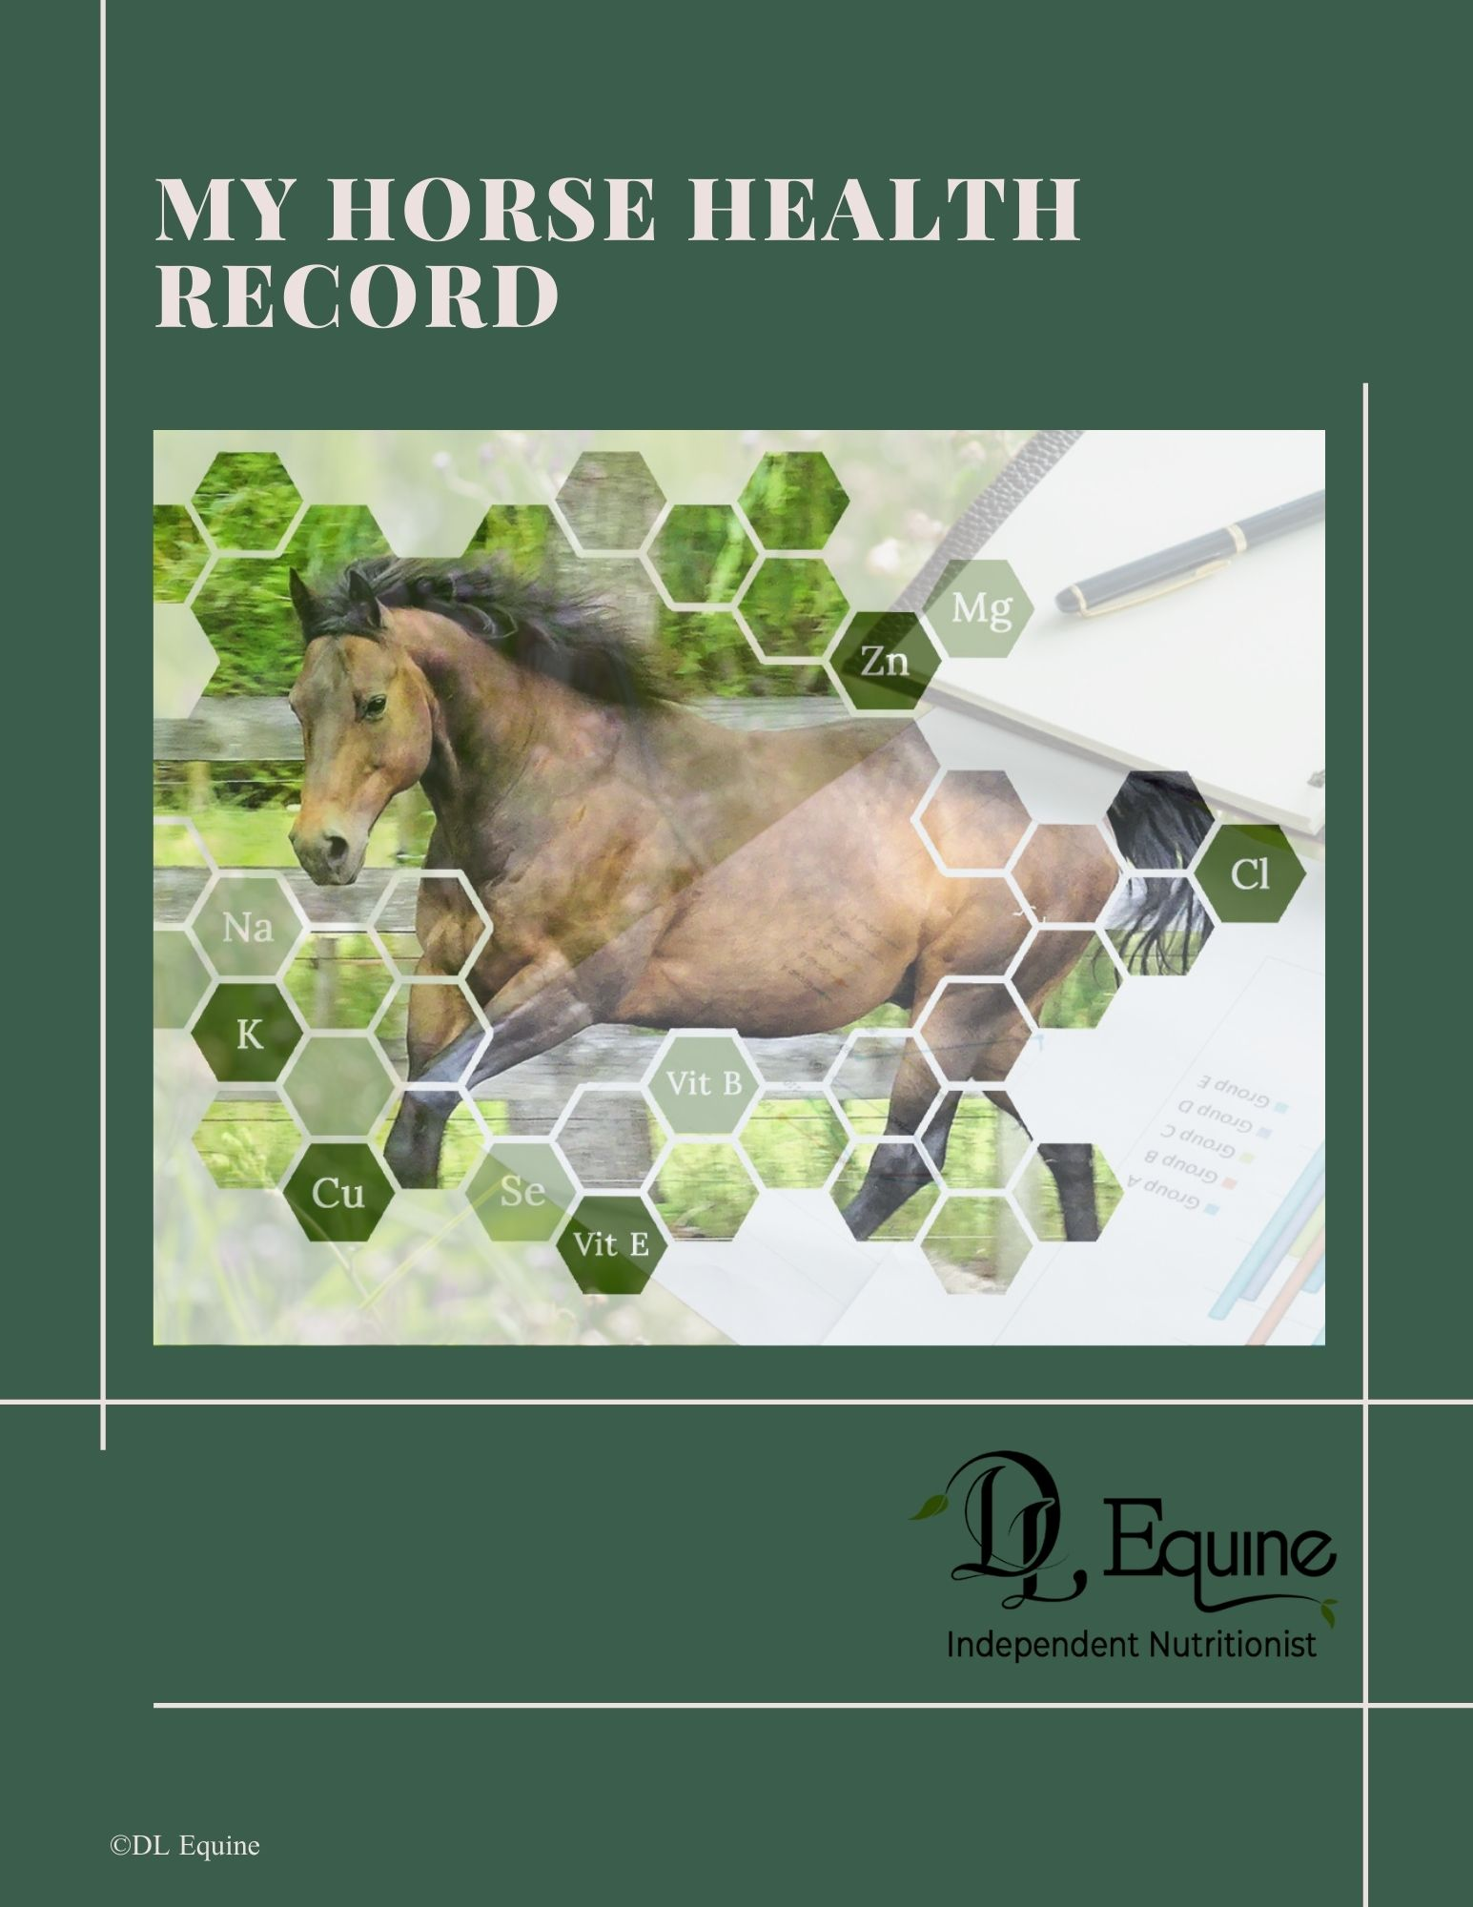

Contents
Health and History 3
Horse 3
Weight 5
Worming History 8
Dental History 9
Vaccinations 9
Farrier 10
Health problems 11
Medication 12
Feed Information Chart 13
Photos 16

Health and History

Horse
Name Owner
Address
Email + ph
Professional Team | Specialty Name Ph  Nutritionist Dale Logan – DL Equine Nutrition 0274 983665  Dentist  Vet  Farrier  Physio  Saddle Fitter
How long owned
Breed
Age
Colour
Sex
Build / Bone
Details of any abnormalities
e.g. scars, injuries
Weight | Height cm  Length cm  Girth cm  Neck cm
 | Weight kg = (Girth cm x Girth cm) x Length cm ÷ 11877
Date  Weight  Date  Weight  Date  Weight  Date  Weight  Date  Weight | Height cm  Length cm  Girth cm  Neck cm  Height cm  Length cm  Girth cm  Neck cm  Height cm  Length cm  Girth cm  Neck cm  Height cm  Length cm  Girth cm  Neck cm  Height cm  Length cm  Girth cm  Neck cm
Work Load -
Hours per day -Light, hard work..
Water type (bore, creek, main supply)
Urination –
- How often/ flow
- Colour
- Straining
Manure
- Type
- Regular
- Loose
Sweating – heavy/light
Skin / Hair (coarse, fine)
Conformation
Joints – Arthritis? Issues?
Worming History | Wormer Name Date
Dental History | Dentist Date Issues
Vaccinations | Date Type
Breeding and cycling history - mares | Date In Season
Farrier | Date Shoe/ Trim
Health problems  Has your horse ever suffered from?  - Laminitis  - Colic  - Gastric ulcers  - Tying up  - Other | Date Health Issue
Medication  Does your horse currently receive any prescriptions and/or other medications? | Date Medication

Feed Information Chart
WEIGH YOUR HORSES FEED WITH SCALES!
You need the accurate weight of each feedstuff to calculate what your horse is eating
Pasture  - Pasture details – Type Grass e.g. 50% kikuyu, 20% Rye grass, 30% clover? | How many hours per day does your horse have access to pasture?  Type Grass Species %
Hay  (Weight, type, how often) | Type Weight per day
Mixed Feed  - Weight,  - how often, | Feed Brand Weight per day
Supplements  - how often  - weight of each ingredient | Supplement Brand Weight per day
Do you have any of the following for your horse and property?  - Blood tests for nutritional testing  - Pasture or hay testing  - Feed testing | Test Date
Other Information

Photos

Photo 1 Left Side Date

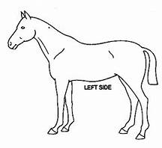

Photo 2 Right Side Date

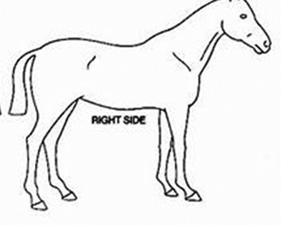

Photo 3 Hind Rear View Date

Photo 4 Front View Date

Dl Equine Independent Nutritionist

https://dlequine.co.nz/

info@dlequine.co.nz

https://www.facebook.com/dlequinenutrition

https://www.instagram.com/dl_equine_nutrition/

Ph 0064 274 983 665

